|  |  |  |
| --- | --- | --- |
| **LAB 321Assignment** | **Type:** | **LongAssignment** |
| **Code:** | **J3.L.P0039** |
| **LOC:** | **250** |
| **Slot(s):** | **10** |

**Title:** The search function

The search page is a facility that help the user easily located their interested information with some key words.

**Program Specifications**

In this assignment, you are requested to develop a search page for a product store

**Features:**

This website contains 3 main functions

* Function 1: Add new product: A new product should contains the information for name, picture, price, discount price, description. (PIC 01)
* Function 2: search form (PIC 02)

The user browse a search form with the text field and a button beside

* Function 3 : Display the search results (PIC 02)

According to the keyword, the program would looking for products with name or description contains the keywords and then display search results on this page.

***Expectation of User interface:***

Pic 01 : Add new product

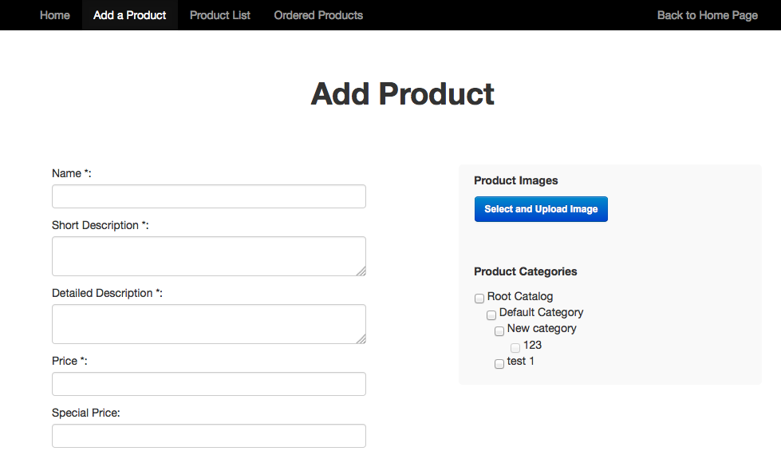

PIC 02: search form

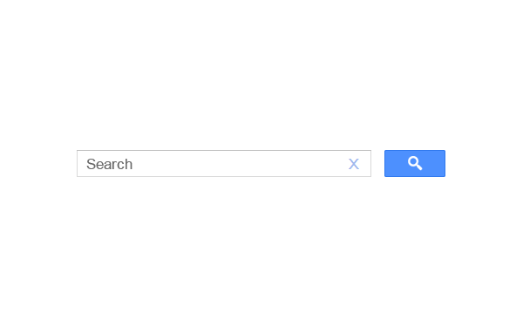

PIC 3 : Search result

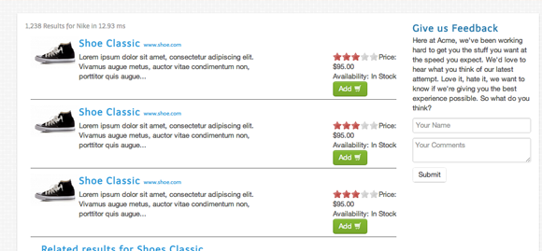

**Guidelines**

* Step 1 : Create web layout
* Step 2 : Create prototype
* Step 3 : Design database base on created prototype
* Step 4 : Code & Test